Continuous Monitoring of Comet Holmes from Before the 2007 Outburst

Ehab E. El-Houssieny1, Robert J. Nemiroff1 & Timothy E. Pickering2

1 Michigan Technological University, Department of Physics, 1400 Townsend Drive, Houghton, MI, 49931, USA

2 MMT Observatory, University of Arizona, Tucson, AZ 85721, USA

Abstract

The outburst and subsequent brightness evolution of Comet Holmes has been observed using the MMT Observatory’s All-Sky Camera (Pickering 2006) on Mt. Hopkins near Tucson, Arizona, USA. The comet was picked up at the limiting visual magnitude of 5.5 on October 24.38 and tracked by the camera continuously until sunrise four hours later. During this time the comet brightened to visual magnitude 3.5. Comet Holmes was next observed just after sunset on October 25.23 at visual magnitude 2.5 where it remained approximately constant over the next three days. The comet then began to dim slowly and was followed into the early months of 2008 with periods of dense time coverage.

1. Introduction

Comets have been noted in the sky for almost as long as history has been recorded. A verifiable light curve for any bright comet is rare, however, since human observers are hard to calibrate, photographic magnitudes can be unreliable for bright objects, and because telescopes with modern CCDs typically have fields of view too small to contain a comet that has reached naked-eye visibility. Even for comets monitored by CCD, unusual cometary events are rarely recorded, since observers are typically alerted to look only after such an event has occurred.

In recent years, however, a class of all-sky cameras has begun to be used routinely in astronomy, primarily to assess sky conditions (Nemiroff & Rafert 1999; Pickering 2006; Shamir & Nemiroff 2005; Shamir & Nemiroff 2005). These cameras typically utilize fisheye lenses with fields of view in excess of 150° and can thus capture images of a comet of almost any size. Furthermore, these cameras typically operate every clear night, and so are likely to be operating during an unusual cometary outburst.

In 2007 October, periodic comet 17P Holmes underwent an unusual outburst which increased its brightness from an apparent visual magnitude of about 17 to near 3. This paper reports details from an all-sky camera that captured this cometary outburst and monitored the brightness of the comet continuously for the next few hours and for many nights over the next three months.

2. A Brief History of Comet Holmes

Comet Holmes was discovered by Edwin Holmes (London, England) on November 6, 1892 within the Andromeda Galaxy (M31). The comet brightened from dimmer than visual magnitude 17 to about visual magnitude 2.8 over about 42 hours, creating a coma about 5 arc minutes diameter (Whipple 1984). The comet's discovery was confirmed by Edward Walter of the Royal Observatory in Greenwich, England (Whipple 1984; Bobrovnikoff 1943). Unexpectedly, Comet Holmes underwent a second outburst only few months later, on January 16, 1893. In the second outburst, the comet brightened to visual magnitude 8 and exhibited a coma of 41 arc seconds in diameter. The comet steadily exhibited a larger coma until late the next night and then steadily faded after the next outburst. The last observation before fading from visibility was made by H. C. Wilson of Goodsell Observatory in Northfield, Minnesota on April 4, 1893 (Bobrovnikoff 1943; Zwiers 1912). The comet was lost after 1906 until being re-acquired on July 16, 1964 by Elizabeth Roemer of the Naval Observatory in Arizona, USA (Whipple 1984).

Several attempts have been made to determine the comet's orbital elements. The first orbit determination was calculated by H. C. Kreutz using three positions measured on November 9, 10, and 11, 1892 (Zwiers 1912). Kreutz discussed the difficulty of calculating Comet Holmes' orbit and introduced four potential parabolic orbits satisfying three observations with perihelion passage time ranging from February 28 – June 7, 1892 and an orbital period of 6.9 years. During the next few weeks, several more attempts were made to more precisely determine Comet Holmes' orbit. These attempts also derived rather different orbital elements with perihelion passage estimates ranging from February 28 to August 16, 1892.

3- The Outburst and the Light Curve of Comet Holmes in 2007-2008

On October 24, 2007, Comet Holmes underwent an outburst similar to its first outburst. During the early hours of October 24, 2007, the comet became much brighter, increasing its brightness from a visual magnitude of about 18 to 2.5 over less than two days. Comet Holmes became the third brightest object in the constellation of Perseus (see Figure 1-b) and was visible to the unaided eyes of even casual observers.

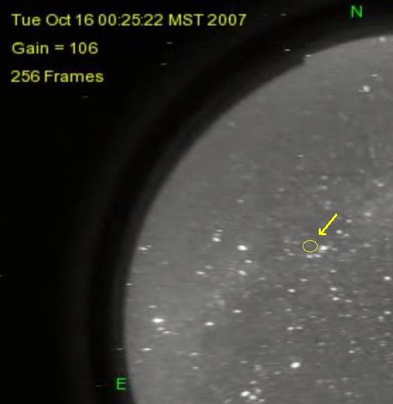  (a) | 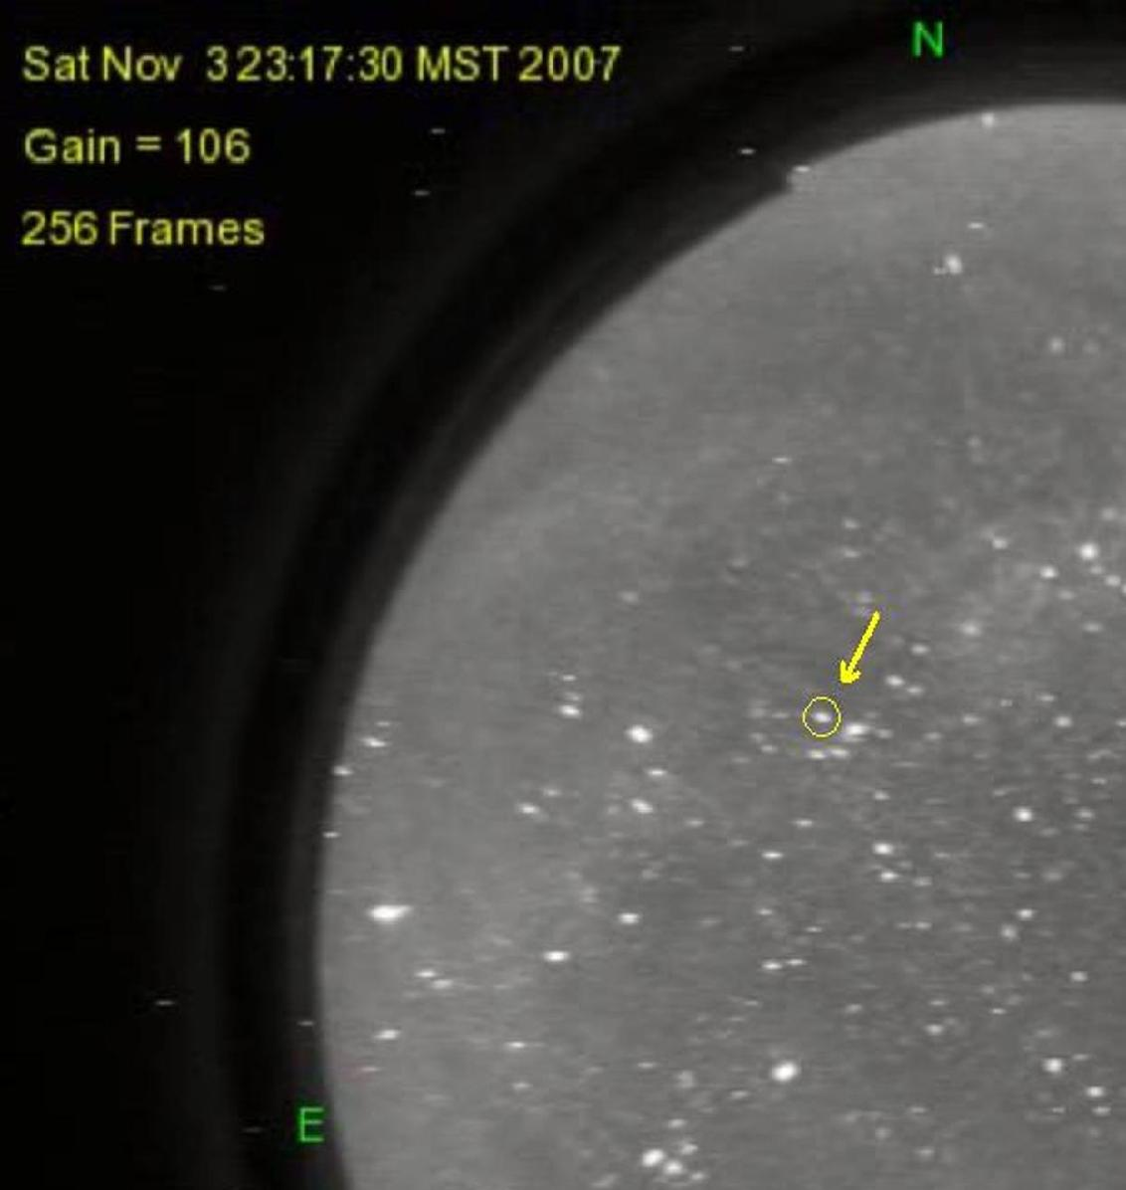  (b)
Fig (1): - Two images extracted from MMTO All Sky Camera image archive. Comet Holmes is barely visible on the image on the left, taken on October 16 when it was fainter than 17th magnitude, while only 18 nights later, at the same sidereal time, the comet is easily visible on the image on the right at a visual magnitude of 2.8.

Although hampered by moonlight, the MMT All-Sky Camera was able to capture Comet Holmes on the night of its sudden brightening. Through the course of its normal operation, the All-Sky Camera was then able to follow the evolution of Comet Holmes for several months after its outburst. On a dark night, the system defaults to an 8.533 second exposure time which results in a limiting magnitude of about 5.5 in V and 6 in R. Sensitivity is decreased by moonlight, however, due to glare, reduced gain, and reduced exposure time.

It was necessary to divide Comet Holmes’ light curve into two graphs according to our continuous observations of the comet from the time it became visible on MMTO All Sky Camera images over the next three months. Figure 2 shows a plot of the visual magnitude of Comet Holmes over the first three days where the comet exhibited extreme magnitude change from below visibility to magnitude 2.5 in less than 24 hours. Data points are plotted for every hour by averaging over each 10-second exposure. While Figure 3 shows a plot of the comet magnitude over the next three months where the comet exhibits steady fading phase. Data points are plotted for every notable magnitude change, nearly for every 24 hours. Magnitude estimates in both graphs were made by comparison to stars of cataloged magnitudes (Henry Draper Catalogue at Harvard College Observatory).

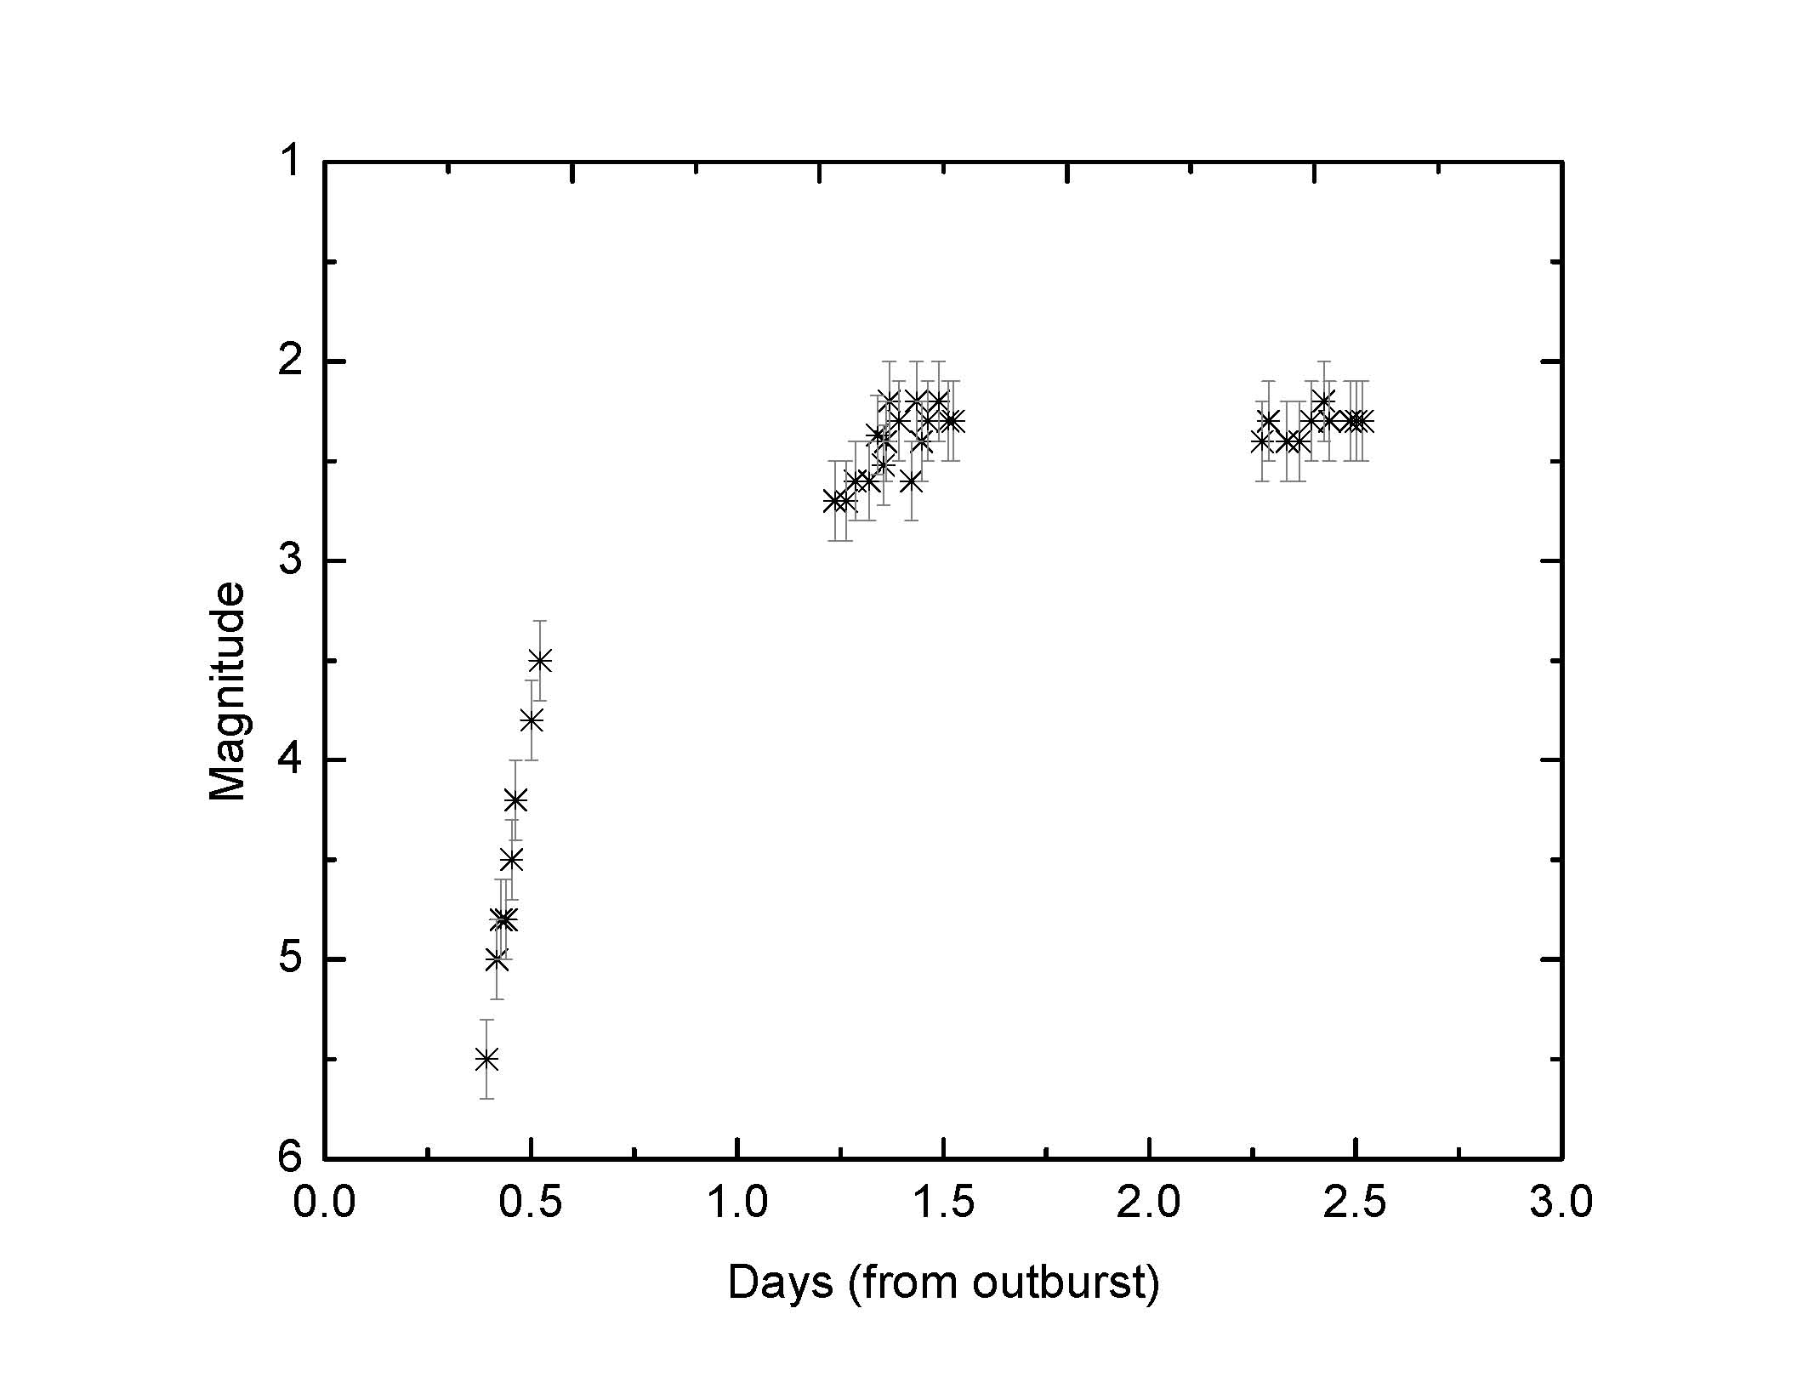
Figure (2): - The Comet Holmes’ light curve from October 24-26, 2007

Figure 2 shows that Comet Holmes started its outburst at the early hours of October 24, 2007, in particular about 9.5 am UT (Universal Time) and it was of magnitude 5.5 to be visible to unaided eyes. In less than 24 hours, comet 17P surprisingly brightened to magnitude 3.5 that is enough to be seen in full-moon night and town light pollution. In the next night, October 25, 2007, at 06:53 am UT, the comet reached magnitude 2.5. This is followed by complete constancy at maximum light sustained for 2 days after the comet outburst.
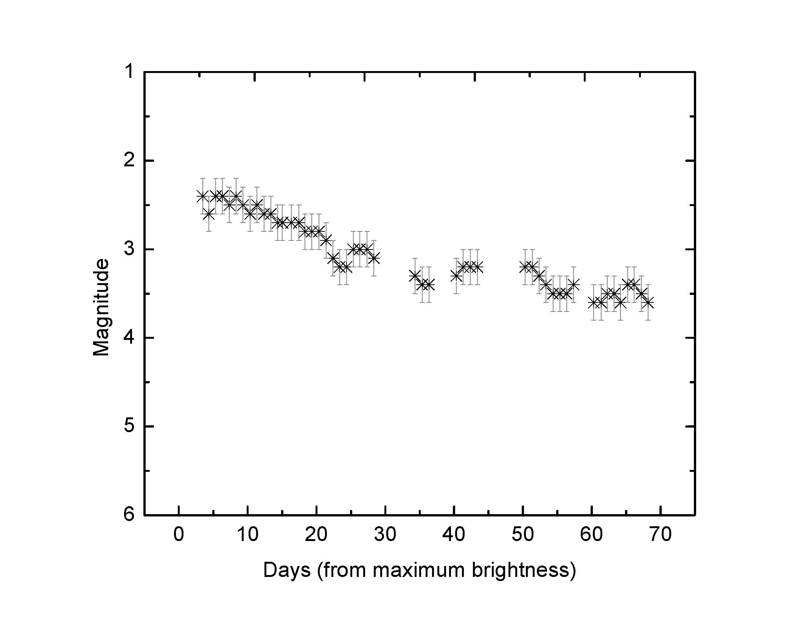
Figure (3): - The Comet Holmes’ light curve from October 27, 2007- January 1, 2008
Figure (3) shows that Comet Holmes remained visible over the next three months. Night to night, from October 27, 2007- January 1, 2008, Comet 17P is slowly and steadily fading through periods of about three days long.

4- Quantifying Comet Holmes' Light Curve
For explanatory and future predictive value, an attempt was made to quantify the evolution of the brightness of Comet Holmes as a function of time. Comet for Windows software (Seiichi Yoshida, 1995-2004) was used to analyze the brightness measurements of comet Holmes and optimize a light curve as shown in Figure (4).

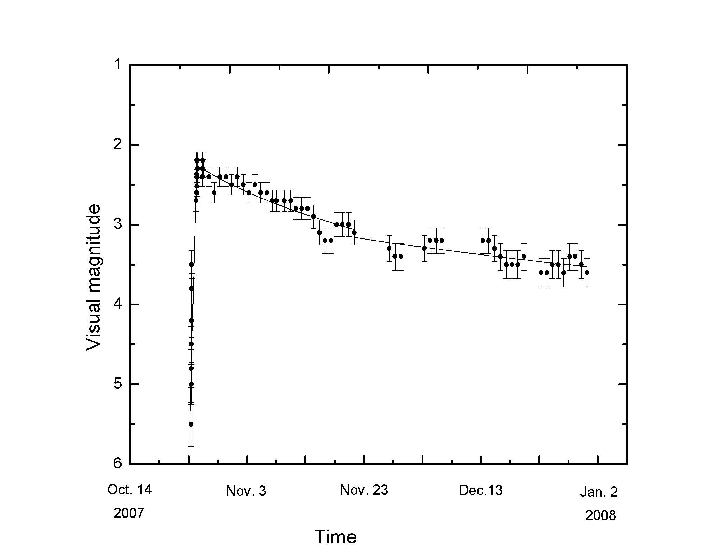

Figure (4): Comet Holmes light curve according to magnitude estimations is drawn by dots and the solid line represents the calculated magnitude formulas for our magnitude estimations.

The light curve is calculated from all brightness measurements as divided into two periods, starting after Comet Holmes flare on Oct. 24, 2007. The magnitude formula, which represents magnitude change over 23 days after the flare, is
m1 = -15.69 + 5 log d + 43.6 log r (from Oct. 24 – Nov. 16, 2007) .
Subsequently, the comet slowly and steadily fading according to
m2 = -1.63 + 5 log d + 8.71 log r (from Nov. 16, 2007 – Jan. 1, 2008) .
where m is the comet’s apparent bolometric magnitude; and d and r are its geocentric and heliocentric distances respectively.

5- Summary and Conclusions

Comet outbursts were discovered many decades ago (Bobrovnikoff 1943 and Zwiers 1912), though a complete picture of such odd occurrences is not resolved yet. Comet light curves provide important information about comet flares (see, for example, Churyumov and Filoneko 1993). In an attempt to provide a clearer picture about this unusual cometary flare, our paper summarizes and analyzes the results of observations of Comet 17P/Holmes' flare that began in October 2008. These observations were taken with the MMTO All Sky Camera over three months from the beginning of its outburst. From the time Comet Holmes became visible to the MMTO All Sky Camera, it brightened from visual magnitude 5.5 to magnitude 2.5 in less than 24 hours, and then brightened only slightly over the next two days. To the best of our knowledge, no similar comet brightening has ever been recorded in such detail by a single dedicated instrument before. After reaching its peak, Comet Holmes steadily faded to fainter magnitudes over the next three months to reach magnitude 3.7 on January 1, 2008. Again, to the best of our knowledge, no comet has ever been monitored by a single dedicated instrument for so long a period of time previously. It is our hope that the Comet Holmes' light-curves presented here will provide useful constraints for future comet outburst models.

Acknowledgments
I gratefully acknowledge support of my travel to the US by the International Astronomical Union (IAU) through the Exchange of Astronomers Programme.

References

- Bobrovnikoff, N. T. “ The Periodic Comet Holmes (1892 III),” PA, 51, 542B, 1943.

- Churyumov, K. I. and Filoneko, V. S., "Phase Dependencies of Cometary Light Curves," Abstracts of IAU Symp. 160: Asteroids, Comets, Meteors, Belgirate (Novara), Italy, , P. 66, June 14-18, 1993.

- Comet for Windows software by Seiichi Yoshida, 1995-2004.

- Henry Draper Catalogue, was compiled by Annie Jump Cannon and co-workers at Harvard College Observatory under the supervision of Edward C. Pickering,

- Nemiroff, R. J. and , Rafert, J. B., “Toward a Continuous Record of the Sky,” PASP, 111, 886-897, July 1999.

- Osamu Ajiki, “Orbit Viewer applet (AstroArts)”, and further modified by Ron Baalke (JPL). http://www.nasa.gov/

- Pickering, T. E., “The MMT All-Sky Camera,” SPIE 6267, June 2006.

- Shamir, L. and Nemiroff, “All-Sky Relative Opacity Mapping Using Nighttime Panoramic Images,” PASP, 117, 835, 972–977, September 2005.

- Shamir, L. and Nemiroff, R. J., “PHOTZIP: A Lossy FITS Image Compression Algorithm that Protects User Defined Levels of Photometric Integrity,” 129, 1, 539–546, Jan 2005.

- Whipple, F. L., "Comet P/Holmes, 1892III: A case of duplicity?" Icarus, 60, issue 3, 1984.

- Zwiers, H. J., “Researches on the orbit of the periodic comet Holmes and on the perturbations of its elliptic motion”, De Roever KroÌˆber & Bakels, 1912.

